Chronos – Distributed Job Scheduler System

1. One-Pager (High-Level Summary)

1.1 Overview
In modern computing environments, being able to efficiently schedule, manage, and monitor tasks, also known as jobs, is crucial. These could range from simple tasks like sending a weekly email to more complex operations like processing data or maintaining databases. This project will have you design and implement a robust and scalable backend for a job scheduling system. Develop a reliable and scalable distributed job scheduling system that can execute, manage, and monitor a variety of tasks. The system should support one-time jobs as well as recurring jobs, providing comprehensive job management functionality. While the system will primarily handle backend functionalities, there should be provision for interaction with a potential frontend through well-defined APIs.In the intricate landscape of modern computing, the efficient scheduling, meticulous management, and vigilant monitoring of tasks—commonly referred to as jobs—are not merely beneficial but absolutely paramount. These jobs can span a vast spectrum of complexity, from the straightforward execution of a weekly email dispatch to the intricate orchestration of data processing pipelines or the ongoing maintenance of robust database systems.

This project embarks on the ambitious endeavor of designing and implementing a resilient and scalable backend infrastructure for a sophisticated job scheduling system. The core objective is to architect a reliable and scalable distributed job scheduling system capable of executing, managing, and meticulously monitoring an eclectic array of tasks. The system must inherently support both ephemeral, one-time jobs and recurring, scheduled tasks, providing a comprehensive suite of functionalities for end-to-end job management. While the primary focus of this system will be on the robust implementation of backend functionalities, it is imperative that provisions are made for seamless interaction with a potential frontend. This will be achieved through the meticulous definition and exposition of well-structured Application Programming Interfaces (APIs), ensuring a clear and efficient communication channel between the backend and any future user interface.

1.2 Key Features
- Job Submission
Users can submit jobs through REST APIs, specifying execution details such as target HTTP endpoint, payload, headers, and execution time. Jobs can be executed immediately or scheduled for a future timestamp.
- Recurring & Cron-Based Scheduling
Chronos supports both simple recurring intervals (e.g., every X minutes/hours) and full cron expressions. The system automatically computes and updates the next_execution_time atomically for recurring jobs, ensuring correct and conflict-free scheduling across multiple application servers.
- Distributed Job Execution
Multiple application servers can run Chronos simultaneously. Each server independently polls for due jobs and uses PostgreSQL's SELECT … FOR UPDATE SKIP LOCKED to safely lock and execute jobs without duplication, enabling true multi-node scalability and horizontal load distribution.
- Robust Job Management
Users can query job status, view execution history, reschedule jobs, modify recurring patterns, or cancel upcoming executions through the exposed APIs. All job state transitions (PENDING → RUNNING → SUCCESS/FAILED/RETRY) are tracked consistently.
- Fault Tolerance & Automatic Retries
Chronos includes a retry mechanism with exponential backoff for transient failures such as network timeouts or 5xx responses. If retries are exhausted or a job repeatedly fails, the system marks it as FAILED and (optionally) notifies the user.
- Execution Heartbeats & Crash Recovery
While a job is executing, the worker thread updates the job’s heartbeat timestamp. If the job exceeds the allowed maximum execution time or heartbeat becomes stale (e.g., server crash), Chronos marks the job as STUCK. Other servers can safely detect and re-execute these jobs, ensuring system resilience.
- Detailed Logging & Monitoring
Every job invocation logs:
  - start time
  - end time
  - response code
  - response time
  - error details
  - execution node

1.3 Technical Highlights
- PostgreSQL-Based Distributed Locking using SELECT … FOR UPDATE SKIP LOCKED for safe multi-node scheduling
- Multi-Node Job Execution with automatic conflict prevention and horizontal scaling
- Atomic Recurring Job Scheduling by updating next_execution_time inside the same DB transaction
- Fault-Tolerant Execution via heartbeat tracking and max-execution watchdog
- Automatic Retry Mechanism with exponential backoff
- Worker Crash Recovery through stale-heartbeat detection and job reassignment
- Spring Boot Microservice Architecture for clean separation of scheduler, executor, and APIs
- ExecutorService-Based Worker Pool for concurrent job execution within each node
- Structured Logging & Execution History stored in PostgreSQL for observability
- Future-Ready Next.js Dashboard (with shadcn/ui) for job monitoring and lifecycle management
- Horizontal Scalability without introducing Kafka/Redis in v1 (DB-driven coordination)

1.4 Project Timeline
Milestone | Target Date | Status
Project Start | 10 Nov 2025 | Started
One Pager Submission | 15 Nov 2025 | In Review
Core Features Complete | 21 Nov 2025 | Not Started
Testing & Debugging | 23 Nov 2025 | Not Started
Final Delivery | 29 Nov 2025 | Not Started

1.5 Contact Info
For more details or inquiries, please contact:

- Name: Muhammed Hilal
- Email: Muhammed Hilal

2. High-Level Design (HLD)

2.1 Architecture Overview
- API Service
A Spring Cloud Gateway receives all incoming API requests and routes them to the appropriate backend services (Scheduler Service or Worker Service). This enables clean separation between job management APIs and background execution components.
- Load Balancer
Multiple instances of each service (Scheduler and Worker) run behind a load balancer. This allows Chronos to scale horizontally:
- more scheduler nodes = faster scanning of due jobs
- more worker nodes = higher throughput for job execution
All nodes interact with the shared PostgreSQL database, relying on distributed locking to prevent conflicts.
- Scheduler Service
The Scheduler Service provides all external APIs for job management:
- Create a job (one-time or recurring)
- Modify job details
- Cancel a job
- View job history or status
Internally, the Scheduler Service also contains:
Due-Job Scanner
A periodic task that:
- Queries PostgreSQL for jobs where next_execution_time <= NOW()
- Uses SELECT … FOR UPDATE SKIP LOCKED to atomically lock each due job
- Updates the job’s next_execution_time for recurring schedules inside the same transaction
- Marks the job as RUNNING and assigns it to the Worker Service by leaving it ready for worker polling
This ensures strict single-execution semantics even across multiple scheduler instances.
- Worker Executor (ExecutorService on each node)
Each Worker Service instance:
- Polls the database for RUNNING jobs that are not assigned to a worker yet
- Claims them using row-level locking
- Submits them to its internal ExecutorService thread pool
- Executes the HTTP call specified in the job
- Updates the job with execution result
- Handles retries using exponential backoff for:
  - network timeouts
  - 5xx server errors
- Writes structured execution logs to the database
Workers operate independently across nodes, making the execution layer fully distributed.
- Heartbeat Liveliness checker
Each job being executed is associated with a “heartbeat” entry:
- The worker thread updates last_heartbeat_at every few seconds.
- If the worker dies or JVM crashes, the heartbeat stops.
- This allows detecting stuck or abandoned jobs.
- When the job finishes, its heartbeat stops and the status is updated.
Heartbeats ensure worker crash recovery across multiple nodes.
- Max Execution Time Checker (Timeout Recovery)
A separate scheduled task on every node monitors jobs in RUNNING state:
- If NOW() – started_at > max_execution_time, the job is considered hung.
- The system marks it as STUCK or RETRY_PENDING.
- Any Worker Service can later re-acquire and retry the job using the same SKIP LOCKED mechanism.
This prevents jobs from hanging forever due to slow or unresponsive endpoints.
- PostgreSQL Database
PostgreSQL acts as the central coordination mechanism for the entire distributed system. It stores:
- job definitions
- next execution timestamps
- lock state
- execution logs
- heartbeat timestamps
- retry counters
- status transitions
PostgreSQL’s row-level locking ensures safe concurrency and no duplicate execution in a multi-node environment.

2.2 Architecture Diagram
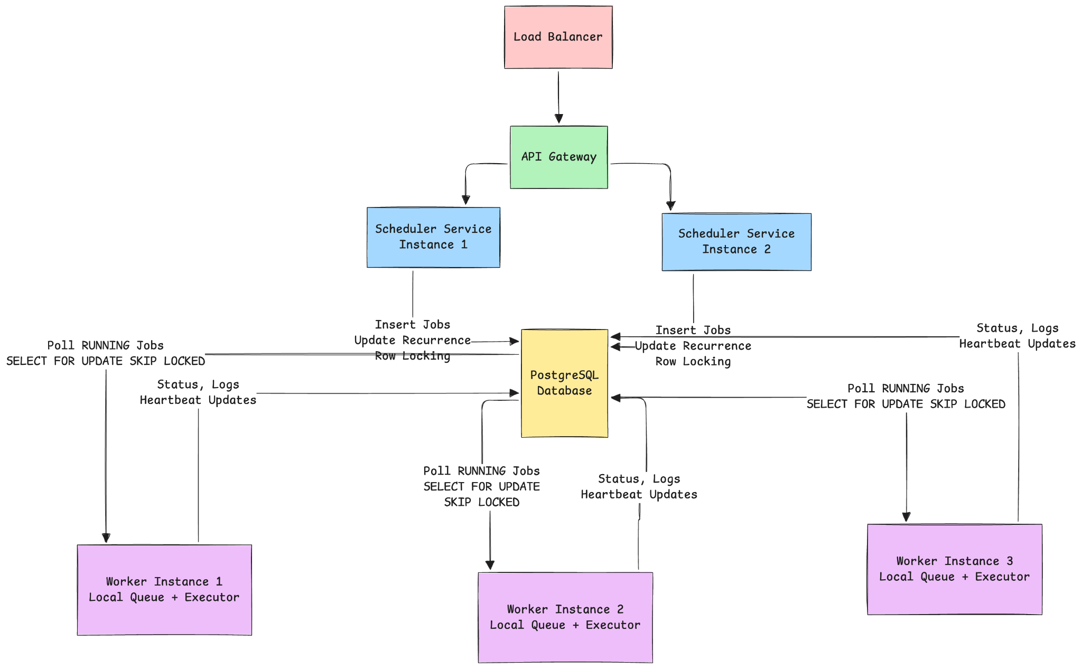

2.3 Job Execution Flow
Explain:
- Job creation → DB
  - A user creates a job through the API, specifying:
    - whether it is one-time or recurring
    - execution time
    - payload and configuration
  - The API validates the request
  - The job is saved in the PostgreSQL database with:
    - status = PENDING
    - next_execution_time set to the user-defined schedule
    - retry_count = 0
    - max_execution_time (if configured)
At this point the job is dormant, waiting for the scheduler.
- Scheduler → picks due jobs
All application servers run the scheduler loop in parallel.
To safely pick jobs without conflict, each scheduler node executes:
SELECT *
FROM jobs
WHERE next_execution_time <= NOW()
AND status = 'PENDING'
FOR UPDATE SKIP LOCKED
LIMIT X;
This ensures:
- Only one scheduler instance locks a job at a time
- Locked rows are skipped by other scheduler nodes
- Multiple schedulers can run concurrently without race conditions
Once a scheduler successfully locks a job, it:
- sets status = RUNNING
- computes and updates next_execution_time (for recurring jobs)
- sets assigned_worker_id (for tracing)
- sets started_at = NOW()
All of these updates occur atomically within the same transaction, ensuring strict single-execution guarantees across distributed nodes.
- Worker executor runs job
Worker Service instances continuously poll the database for jobs that have:
- status = RUNNING, and
- have not yet been picked by a worker
Workers claim these jobs using another SELECT FOR UPDATE SKIP LOCKED, ensuring exclusive ownership.
Once claimed, the job is placed into the worker’s internal ExecutorService thread pool.
During execution:
- the worker thread periodically updates last_heartbeat_at
- a hang checker monitors for unresponsive or stalled execution
- any exception is captured and logged
On completion, the worker updates the job in the database with:
- final status (SUCCESS / FAILED / RETRY_PENDING)
- execution logs
- timestamps
- Updates job state
The final job state is always written back to the database, ensuring accurate tracking for monitoring, retries, and history queries.
- Execution Completion Handler (Post-Execution Processing)
Every scheduler node runs a periodic task to process finished executions:
- Scan the job_executions table for rows where status IN ('SUCCESS','FAILED','TIMED_OUT') and not yet processed.
- For each finished execution:
  - If SUCCESS:
    - For recurring jobs → compute & update next_execution_time
    - Set job status = PENDING
  - If FAILED or TIMED_OUT:
    - If retry_count < max_retry:
      - increment retry_count
      - compute backoff delay
      - update next_execution_time
      - set job status = PENDING
    - Else:
      - set job status = FAILED
      - next_execution_time = NULL ( For one time executions else schedule the next run)
- Mark the execution entry as processed (or rely on timestamps to skip old ones)
This ensures correct rescheduling and safe retries across nodes.

2.4 Recurring Job Flow
For recurring jobs, the scheduler computes the next occurrence before execution starts.
This is done inside the same transaction that sets the job to RUNNING, guaranteeing:
- no missed intervals
- no double scheduling
- deterministic recurrence behavior
The formula for calculating the next execution is based on the user’s defined interval (e.g., hourly, daily, custom cron-like values).

2.5 Distributed Coordination
Chronos achieves distributed behavior through PostgreSQL’s row-level locking and stateless service design.
Multiple application servers reading from the DB
Both Scheduler and Worker Services run as multiple instances behind a load balancer.
All nodes access the same shared PostgreSQL database.
How locking prevents duplicates
SELECT … FOR UPDATE SKIP LOCKED ensures:
- only one scheduler can pick a pending job
- only one worker can claim a running job
- no two nodes can ever execute the same job simultaneously
How crash recovery works
Workers update a last_heartbeat_at field while executing jobs.
If a node crashes:
- heartbeat stops
- timeout checker identifies stalled jobs
- their status is reset to allow retry
- any healthy worker can safely re-acquire the job using SKIP LOCKED
This provides fault tolerance across distributed worker nodes.

2.6 Scalability Strategy

Horizontal Scaling of Application Servers
Both Scheduler and Worker services can scale independently by simply adding more instances.
More schedulers = faster detection of due jobs
More workers = higher execution throughput
PostgreSQL Locking Behavior
Row-level locks and SKIP LOCKED provide natural distributed coordination without external systems like Redis or Zookeeper.
Batching + Indexing
Indexes on next_execution_time, status, and assigned_worker_id ensure efficient scanning even with large job volumes.
Schedulers query jobs in small batches to reduce lock contention.
Fault Tolerance
Heartbeat-based liveliness checks and timeout monitors ensure:
- detection of stuck jobs
- safe re-execution after crashes
- no job left in indefinite-running state
Retry Mechanism with Exponential Backoff
Failed jobs transition to RETRY_PENDING.
The scheduler recalculates the next retry time using exponential backoff to reduce load during repeated failures.

3. Low-Level Design (LLD)

3.1 DB Schema
Tables:
- Jobs
id (PK)
status ENUM('PENDING','SCHEDULED','DISABLED')
payload JSONB
is_recurring BOOLEAN
interval_seconds INTEGER
next_execution_time TIMESTAMPTZ
retry_count INTEGER
max_retry INTEGER
max_execution_time INTEGER
enabled BOOLEAN
Picked_by_worker BOOLEAN
created_by VARCHAR
created_at TIMESTAMPTZ
updated_at TIMESTAMPTZ
- job_executions
id (PK)
job_id (FK → jobs.id)
status ENUM('RUNNING','SUCCESS','FAILED','TIMED_OUT','RETRYING')
worker_id VARCHAR
started_at TIMESTAMPTZ
finished_at TIMESTAMPTZ
last_heartbeat_at TIMESTAMPTZ
retry_number INTEGER
log TEXT
- user_authentication
id (PK)
username VARCHAR UNIQUE
password_hash VARCHAR
roles TEXT[]
created_at
updated_at

3.2 Scheduler Logic
- Cron to Scan Due Jobs
Each Scheduler Service instance runs a lightweight periodic task (e.g., every 1–5 seconds).
This cron task is responsible for identifying jobs whose next_execution_time has passed and preparing them for execution.
The cron does:

- Scan the jobs table for due jobs
- Lock and claim each job safely
- Update scheduling metadata
- Mark the job as ready for workers
- All operations happen inside a small, fast transaction
Multiple scheduler nodes can run this cron simultaneously without conflicts.

- SQL Queries Used
To safely pick due jobs in a distributed environment, the scheduler uses:
SELECT *
FROM jobs
WHERE next_execution_time <= NOW()
AND status = 'PENDING'
FOR UPDATE SKIP LOCKED
LIMIT X;
Once a row is locked, the scheduler performs an update:
UPDATE jobs
SET status = 'RUNNING',
started_at = NOW(),
next_execution_time = :computed_next_time,
updated_at = NOW()
WHERE id = :jobId;
These statements run inside a single transaction to enforce atomicity.
- How Locking Works
PostgreSQL ensures strong consistency using row-level locks:
- When a scheduler instance calls SELECT … FOR UPDATE SKIP LOCKED, the DB immediately locks the rows it returns.
Other scheduler nodes attempting the same query:
  - skip locked rows
  - only pick currently unlocked rows
- This allows multiple schedulers to run in parallel without conflicts or duplicates.
Locks are released as soon as the transaction ends, so workers can pick jobs immediately.
This eliminates the need for external locking systems such as Redis, Zookeeper, or leader election.
- How Next Execution Is Computed
The scheduler computes the next execution time before the worker executes the job.
One-Time Jobs
- next_execution_time = NULL
- status will later be set by completion handler
Recurring Jobs
Computed as:
next_execution_time = previous_next_execution_time + interval_seconds
This happens inside the same transaction that marks the job as RUNNING, ensuring:
- No missed intervals
- No duplicate schedules
- Same behavior across all distributed scheduler nodes
When previous execution failed
If the previous run ended with FAILURE or TIMEOUT:
- If retry_count < max_retry → scheduler computes backoff-based next_execution_time
- If retry_count >= max_retry → scheduler computes next normal interval run and resets retry_count for recurring jobs
This ensures retries are bounded and that recurring jobs continue indefinitely.
- Scan for Completed or Failed Executions (Post-Execution Processing)
In addition to scanning for due jobs, every Scheduler Service instance runs a second periodic task that processes completed job executions.
The scheduler scans the job_executions table for executions where:
status IN ('SUCCESS', 'FAILED', 'TIMED_OUT') AND not yet processed
For each finished execution:
If SUCCESS:
- Recurring jobs:
    - Reset retry_count = 0
    - Set job status = PENDING
- One-time jobs:
    - Set job status = SUCCESS
- If FAILED or TIMED_OUT:
- Recurring jobs:
    - If retry_count < max_retry:
      - increment retry_count
      - compute retry backoff
next_execution_time = NOW() + backoff(retry_count)
      - set job status = PENDING
    - Else (retry_count >= max_retry):
      - reset retry_count = 0
      - compute next regular interval run
next_execution_time = previous_next_execution_time + interval_seconds
      - set job status = PENDING
- One-time jobs:
    - If retry_count < max_retry:
      - increment retry_count
      - compute retry backoff
      - set job status = PENDING
    - Else:
      - set job status = FAILED
      - set next_execution_time = NULL

3.3 Worker Execution Lifecycle
- ExecutorService
Each Worker Service instance contains an internal ExecutorService thread pool that executes jobs concurrently.
The job lifecycle inside the worker is:
- Worker polls the jobs table for entries with:
  - status = 'RUNNING
  - and not yet picked by any worker
(using FOR UPDATE SKIP LOCKED to safely claim the job)
- Once a job is claimed, the worker:
  - marks it as picked (e.g., picked_by_worker = true or similar)
  - creates a new entry in job_executions with:
    - status = 'RUNNING'
    - started_at = NOW()
    - retry_number = current retry_count
    - worker_id = this instance’s ID
- The job payload is submitted to the ExecutorService thread pool for execution.
The worker does not hold any database lock during execution.
- Heartbeats
To detect crashes or stuck tasks, each executing job emits periodic heartbeats:
- A scheduled heartbeat thread updates:
job_executions.last_heartbeat_at = NOW() every few seconds.
- If the worker process or thread crashes, the heartbeat naturally stops. The scheduler later detects stale heartbeats and treats the execution as a hung job.
This mechanism enables distributed crash recovery without a worker registry.
- Max execution timeout
Every worker runs a background timeout checker that monitors all RUNNING executions.
A job is considered “hung” when:
NOW() - started_at > max_execution_time
On timeout:
- The worker updates job_executions.status = 'TIMED_OUT'
- finished_at is set
- A failure log is stored
- The worker stops tracking the job
The scheduler will later reschedule or retry the job according to retry logic.
This ensures no job runs indefinitely due to unresponsive external systems.
- Status transitions
Jobs transition through the following states:
- PENDING
The job is scheduled and waiting for the scheduler to pick it.
- RUNNING

Scheduler sets:
- status = 'RUNNING'
- started_at = NOW()
- next_execution_time (precomputed for recurring jobs)Worker picks the job and creates a job_executions record.
- SUCCESS
The job logic completes without errors.
Worker updates:
- job_executions.status = 'SUCCESS'
- finished_at = NOW()
- log (optional)
Scheduler later sets:
- job.status = PENDING (for recurring)
- OR job.status = SUCCESS and disables further execution (for one-time)
- FAILED
If the job throws an exception, returns an error, or explicitly fails:
Worker updates:
- job_executions.status = 'FAILED'
- finished_at = NOW()
- log with error details
Scheduler later decides:
- retry (if retry_count < max_retry)
- or mark permanent failure (one-time jobs)
- RETRY_PENDING
Not an explicit worker state — but a scheduler state.
Worker reports failure → scheduler computes backoff and sets status back to PENDING for retry.

3.4 Retry & Backoff Design
- Configurable retry count
Chronos allows users to specify the maximum number of retries for any job:
- max_retry is stored in the jobs table
- retry_count tracks how many times the job has retried so far
- Scheduler increments retry_count only after a FAILED or TIMED_OUT execution
- Workers never modify retry_count
Once retry_count reaches max_retry:
- One-time jobs → permanently marked as FAILED
- Recurring jobs → skip retrying this run and continue with the next scheduled interval
This ensures predictable retry behavior and prevents infinite retry loops.
- Backoff algorithm
retry_delay = base_delay * (2 ^ retry_count)
Chronos uses an exponential backoff.

3.5 Error Handling
- Transient failures
Transient failures are temporary issues that are likely to succeed if tried again.
Worker behavior:
- Worker marks the job execution as FAILED
- Records error details into job_executions.log
- Sets job_executions.status = FAILED
Scheduler behavior:
- If retry_count < max_retry:
  - Increment retry_count
  - Apply exponential backoff to compute retry delay
  - Set job status = PENDING for retry
- No need to disable or stop the job
- Recurring jobs continue their next scheduled interval regardless of failure
This ensures that transient issues do not permanently disrupt the system.
- Permanent failures
Permanent failures occur when retrying will not fix the issue.
Worker behavior:
- Marks job_executions.status = FAILED
- Logs full error traceback or message
Scheduler behavior:
- If max_retry is reached:
  - One-time jobs:
    - Mark job status = FAILED
    - Set next_execution_time = NULL
  - Recurring jobs:
    - Reset retry_count = 0
    - Continue with the next scheduled recurring run
    - (Recurring jobs must NOT be canceled permanently)
This ensures fatal errors stop one-time jobs, but recurring jobs remain healthy.
- Dead letter behavior
Chronos provides a simple dead-letter mechanism through historical storage:
- All executions (success or failure) are recorded in job_execution.
- When a job permanently fails:
  - Its last execution entry functions as the "dead-letter record"
  - All past retries and failure logs remain available for debugging
Dead letter queue is NOT a separate table in v1.
Instead, Chronos treats:
job_executions where status = FAILED AND job.status = FAILED
as your effective dead-letter entries.

4. REST API Endpoints

Endpoint | Method | Description
/jobs | POST | Create a one-time job
/jobs/recurring | POST | Create a recurring job
/jobs/{id} | GET | Retrieve job details and current status
/jobs/{id} | DELETE | Cancel/disable a job
/jobs/{id}/executions | GET | Fetch execution history for a job
/jobs | GET | List all jobs (optional filtering)
/jobs/{id}/retry | POST | Force a manual retry of a job (optional)
/monitoring/jobs | GET | System-wide job statistics
/monitoring/workers | GET | Worker health metrics (optional)
/auth/login | POST | Authenticate user and return JWT token
/auth/signup | POST | Create a new user

5. Implementation Details

5.1 Technologies Used
- Spring Boot
Used to build both the Scheduler Service and Worker Service.
Provides REST APIs, background tasks, and dependency injection.
- ExecutorService
The Worker uses Java’s ExecutorService for parallel job execution through a configurable thread pool.
- PostgreSQL
Stores job definitions, execution history, and coordinates distributed scheduling using
SELECT … FOR UPDATE SKIP LOCKED.

5.2 Design Decisions
Brief justification for:
- Why Postgres locking
PostgreSQL row-level locks with SKIP LOCKED provide a reliable and simple distributed coordination mechanism:
- Prevents multiple scheduler nodes from picking the same job
- Prevents multiple worker nodes from executing the same job
- No need for external locking systems like Redis or Zookeeper
- Strong transactional guarantees (ACID)
- Allows full horizontal scaling of both schedulers and workers
This keeps the system lightweight yet fault-tolerant.
- Why no queue (for now)
A message queue (Kafka, RabbitMQ, etc.) is not required in v1 because:
- PostgreSQL already guarantees safe single-worker job assignment
- Workers can directly poll the DB for RUNNING jobs
- Adding a queue increases operational complexity
- No need for decoupling scheduler → worker communication at current scale
Queues may be considered in future versions if throughput reaches extremely high levels.
- Why multi-node architecture
Both the Scheduler and Worker Services are built to run as multiple instances:
- Multiple Scheduler nodes process due jobs faster
- Multiple Worker nodes increase execution throughput
- Stateless services allow load balancers to distribute requests evenly
- The shared database ensures consistency across all node.
This architecture enables fault tolerance and linear scalability.

5.3 Observability
- Log structure
Chronos logs essential events for debugging and auditability:
- Job creation
- Job picked by scheduler
- Worker claiming a job
- Heartbeat updates
- Job execution start/end
- Failures and exceptions
- Retry attempts
- Timeout events
Execution-level logs are stored persistently in the job_executions.log field.
- Monitoring metrics
The system can expose metrics such as:
- Total jobs created
- Pending jobs
- Running job
- Successful / Failed / Timed-out executions
- Average execution time
- Retry counts
- Stuck/hung job count
- Worker throughput
- Scheduler scan latency
These metrics help operators track health and performance.
- Tracking failures
Failures are handled at two layers:
- job_executions table
    - Stores statuses per execution
    - Captures logs, timestamps, and retry number
- jobs table
    - Tracks retry_count, max_retry
    - Stores final job status (SUCCESS, FAILED, DISABLED)
    - Records next_execution_time for future scheduling
This structure ensures that both real-time job state and historical executions are fully traceable.

6. Frontend Plan (Next.js + Shadcn)

6.1 Dashboard Pages
- Jobs List Page
Displays all jobs with their current status (PENDING, RUNNING, SUCCESS, FAILED).
Includes filters for recurring jobs, failed jobs, and next execution time.
- Create Job Page
Form to create one-time or recurring jobs.
Inputs include payload, interval, max retries, and execution time.
- Job Details & Execution Logs Page
Shows job metadata and a table of past executions with timestamps, status, and logs.
- System Health Monitor Page
Shows simple metrics like:
  - total jobs
  - running jobs
  - failed jobs
  - worker node count
  - scheduler activity
Minimal charts or counters only.

6.2 UI Components
Shadcn Forms
Used for job creation and editing:
- text inputs
- number pickers
- JSON editors
- date/time pickers
Tables
shadcn DataTable components for:
- job list
- execution logs
- worker status list
Charts (Light Usage)
Simple line or bar charts (using Recharts) for:
  - job success vs failure
  - execution duration trends

7. Future Enhancements
- Queue-based execution (Kafka/Redis)
- Multi-tenant support
- Worker autoscaling
- Priority scheduling
- Cron expression support

8. Appendix
- Sequence diagrams
- Job Creation
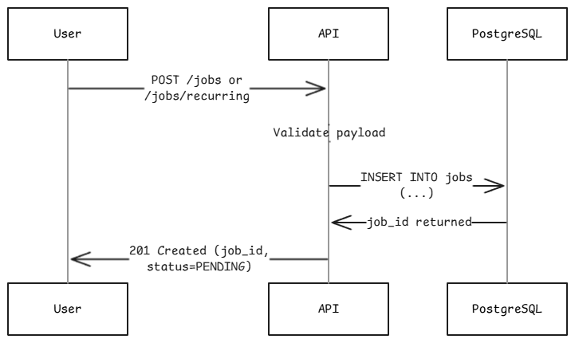
- Scheduler Scans and Picks Due Jobs
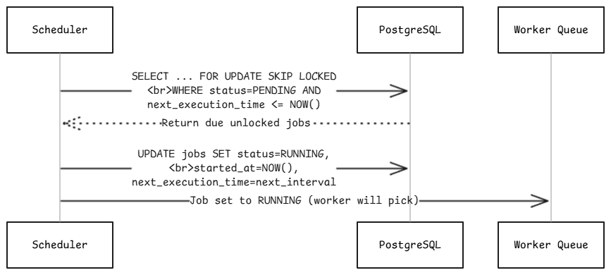
- Worker Execution Lifecycle
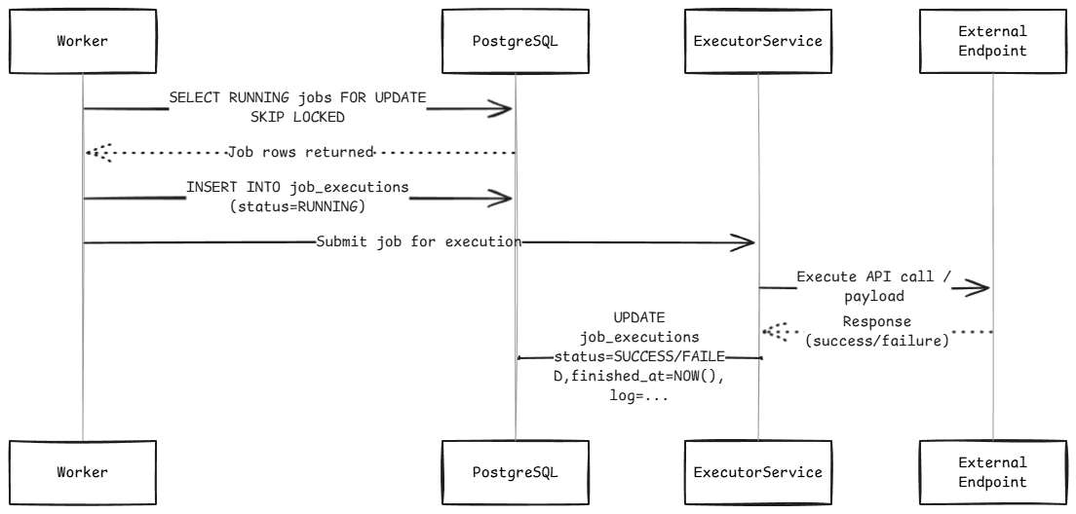
- Execution Completion Handler
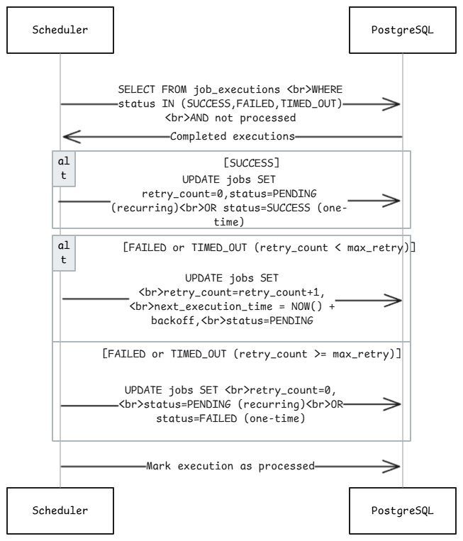
- Retry Flow (Transient Failure)
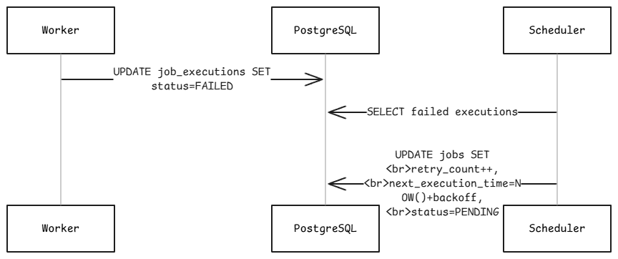

- Timeout / Heartbeat Failure Recovery

